# SANJALIKA WATERPARK SLIDE’S DESCRIPTION WITH MORE FEATURES

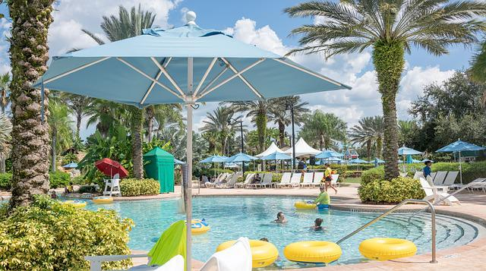

Figure sanjalika waterpark

Sanjalika Water Park is definitely an ultimate and out of the world source of entertainment. Decorated by mermaids, other statues, the Sanjalika Water park has largest cave and swimming pool area of modern technology a kind of place for thrills and fun. At Sanjalika Water park there is lot of water rides which are very exciting and thrilling.

In this document, you are gonna learn about more features of the slides with their information.

MULTI SLIDE

Water parks are amusement parks that consist of lots of slides, playgrounds, swimming pools and lots of other areas which are full of water but are covered with various roundabouts. Water parks are mostly the favorite place to visit for every child and a lot of families during the summer visit various water parks as well. There are a lot of famous water parks around the world, and here a few of those water parks would be discussed where one can enjoy a **water park picnic** with his family.

FEATURES OF THE MULTI SLIDE

● many person can play at same time  
● suitable for indoor and outdoor  
● can share the tower with other equipment  
● Use top material to make sure the safety and steady of water slide  
  
Multislide is one kind of integrated wave speed water slides which can deliver exciting and racing experience. We can supply such slide with 3-8 lanes and platform from 6 to 14meters according to your request.  
  
You can slide down one by one under the lubrication of water and gravity through the spiral entrance and steep slide. Visitors will experience a wonderful feeling during the journey.

MORE FEATURES

|  |  |
| --- | --- |
| **Width** | 0.6m |
| **Capacity** | 1person/lane |
| **Typical Platform height** | 15m |
| **Stretched Length** | 100m |
| **Floor space** | Customized |
| **Mats** | Yes |
| **Tubes** | No |
| **Rafts** | No |
| **Production Method** | RTM |

MULTI SLIDE IMAGES

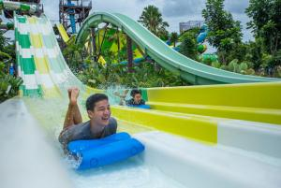

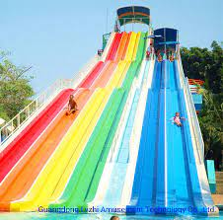

And many more images, customer feedback on such slides have always been good and keeps getting better.

Thank you!